**IBEHS 3A03**

**Assignment 1 – Properties of Systems**

October 5, 2021

Cai, Sharon

Motsenyat, Ariel

**System 1:**

**Causality**

Causality concerns the impact of the future input on current output, with a system being causal if it’s output at time *t* does not depend on inputs at times greater than *t*. A causal system cannot have a nonzero output until a nonzero input is applied. For all three systems, the impulse function, step function, and ramp function are used as test cases since they cover a significant range of input signal options.

In every set of graphs in Figure 1, the output, y[n], does not have a value before it’s input, x[n], does. In the first set of graphs, the impulse function is used as an input and only results in an output when there is a nonzero input. Likewise, in the second set of graphs, the step function is used as an input with values starting at 0 and the output follows this pattern. As well, the ramp function was used as the third input to further confirm that there is never a nonzero output before a non-zero input. As such, system 1 is **causal**.

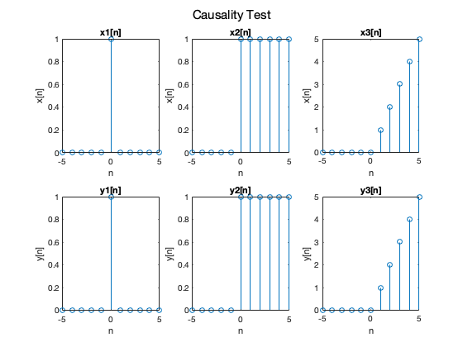

Figure 1. Results after testing causality of System 1

**Linearity**

Linearity is dependent on homogeneity and additivity. Both must be applicable for a system to be considered linear.

Homogeneity

The property of homogeneity requires the system output to be scaled by the same factor as the system input. The test cases for this property are the step, impulse, and ramp functions scaled for the purpose of comparing the original output to the newly scaled output.

As seen in Figure 2, testing scaled versions of the step function and impulse function give rise to appropriately scaled outputs, by respective factors of 3, to scale in the positive direction, and –5, to scale in the negative direction. However, when using the ramp function as the last set of inputs and outputs — the four graphs on the far right — the output is scaled by a different constant than the scaled input. As a result, this system is non-homogenous and is thus, **non-linear.** There is no need to test for additivity.

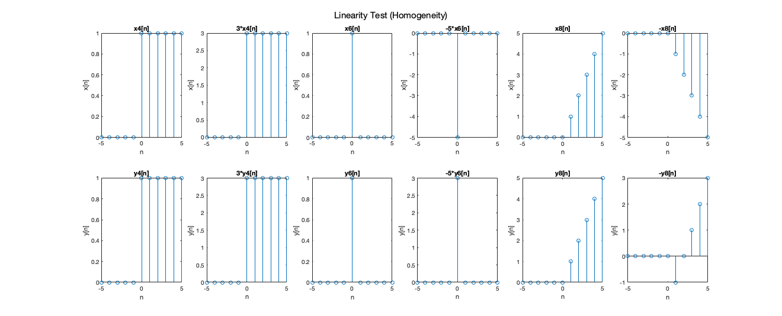

Figure 2. Results after testing homogeneity of System 1

**Time-Invariance**

A system is considered time-invariant if its properties do not change over time. If the output changes beyond being time-shifted by the same amount as the input, the system must be time varying. Shown in Figure 3, the first test case for this property shifts the step function by 2 to the left to test a negative shift. The second test case shifts the impulse function by 3 to the right to test a positive shift. The final test case shifts the ramp function by 4 to the left to test a more complex case. Each of these test cases result in an output that is shifted by the appropriate amount. Thus, this system is **time-invariant**.

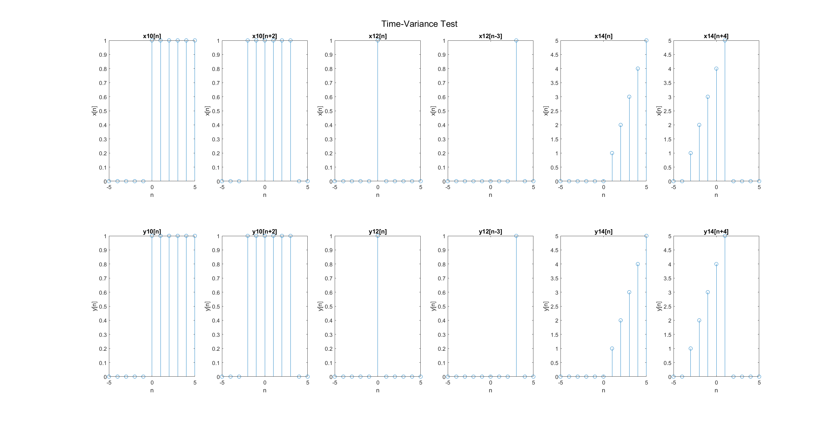

Figure 3. Results after testing time-invariance of System 1

**Memory**

Memory refers to a system’s ability to store information of past and future inputs. In a memoryless system, outputs depend solely on present input and are not affected by past or future input. The system will be considered memoryless if a change of input at time step *t* results in a change in output only at time step *t*. In order to test this property, inputs are used that test with past inputs, at n < 0, or future inputs, at n > 0, influence the output beyond its designated time step.

The original input and its corresponding output are compared first to an input with an added value at a negative time step. As seen in Figure 4, the change in output is restricted to the time step of the added input. The same is true when an input with additional values at positive time steps is used for comparison. Thus, only the present input has an impact on the output and system 1 is **memoryless**.

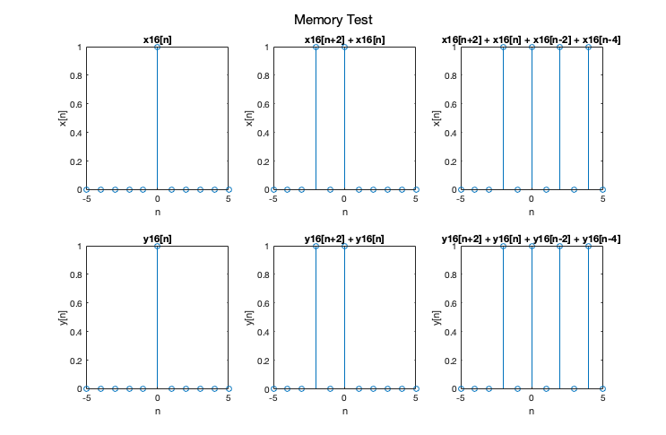

Figure 4. Results after testing memory of System 1

**System 2:**

**Causality**

Using the same approach to test causality as in system 1,the three inputs used are the impulse function, step function, and ramp function. These test cases were chosen to ensure that the results could be compared to one another, as such, each of the findings corroborates the others. As seen in Figure 5, every one of these inputs results in an output that has a non-zero value before a non-zero input. For instance, the first set of graphs demonstrates that with a unit impulse function whose first non-zero input is at n = 0, the resultant output has a non-zero value at n = -1. Thus, based on the definition of causality, this system must be **non-causal**.

Figure 5. Results after testing causality of System 2

**Linearity**

To be a linear system, system 2 must be both homogeneous and additive. Thus, two separate tests must be performed.

Homogeneity

As seen previously, the homogeneity of a system is tested by the scaling of inputs. If the outputs change by the same factor as the input, the system is considered homogenous. For the first test case in Figure 6, the output of a step function input is compared to the output of step function input scaled by a factor of 3. This latter output is scaled by the appropriate factor of 3. Likewise, the impulse function scaled by a factor of –5 and the ramp function scaled by a factor of –1 provide the same conclusions. Since the scaling property holds, system 2 is considered *homogenous*.

Figure 6. Results after testing homogeneity of System 2

Additivity

Since system 2 is homogenous, tests for additivity were also conducted. A system is considered additive if the sum of two inputs is taken as an input and provides an output that is equal to the sum of the two outputs corresponding to the aforementioned two inputs. In Figure 7, x19[n] and x20[n] correspond to the outputs y19[n] and y20[n] respectively. The using the sum of these inputs, x19[n] + x20[n], as an input provides an output that is equivalent to the sum of y19[n] and y[20]. The same property holds for the second test case which uses x22[n] and x23[n] as inputs. Thus, system 2 is *additive* and homogenous, proving that it is **linear**.

Figure 7. Results after testing additivity of System 2

**Time-Invariance**

As previously described, if the system is time-invariant a time-shifted input will lead to a shifted output that is shifted by the same amount. Using the same methods as system 1, three different test cases are used, each of which demonstrates a shift to the right or left. From Figure 8, the first test case using the step function, the input shifted by 2 to the left results in an output that is shifted by 2 to the left, which is the appropriate time-shift. Likewise, in the second test the same time-shift as the input is applied to the output. As well, in the third test case, a shift by 4 to the left is reflected appropriate in the output. As such, system 2 is **time-invariant**.

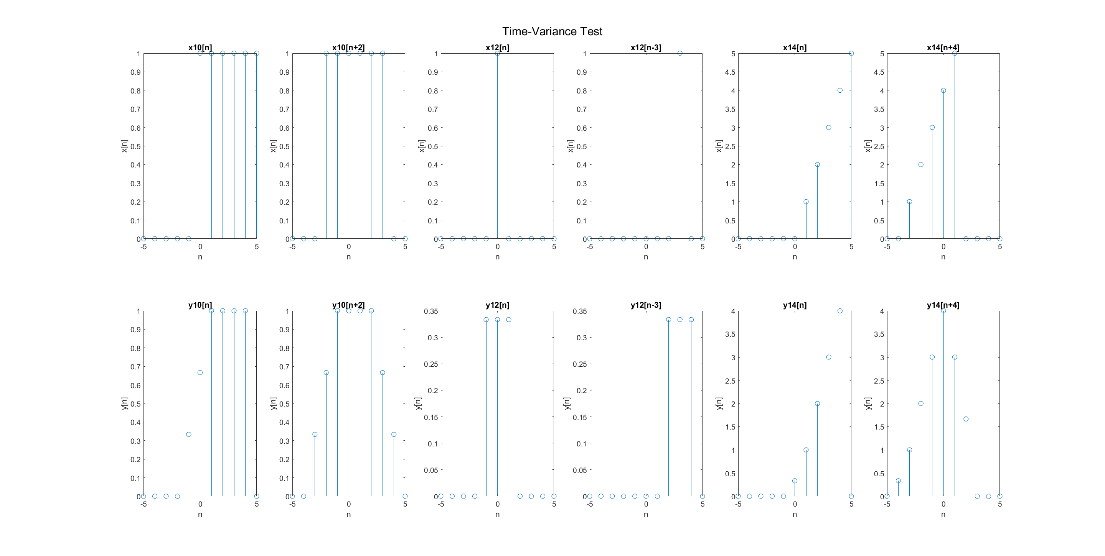

Figure 8. Results after testing time-invariance of System 2

**Memory**

Memory is tested in the same way referenced in the system 1 test. Shown in Figure 9, in each of the test cases, there is a non-zero output value before a non-zero input value. For instance, in the first test case, there is an output at n = -1 when the input is at n =0. Therefore, system 2 has **memory**.

Figure 9. Results after testing memory of System 2

**System 3:**

**Causality**

As previously mentioned, causal systems cannot have a non-zero output until a non-zero input is applied. In figure 10, the three inputs are shown at the top, with the respective outputs shown at the bottom. The first input has a value of 1 at n=0, which results in the same output. For the second set of graphs, addition values of 1 are inputted at n = {1,2,3,4,5}, this results in outputs at the same n values. Finally, the ramp function is used as input for the final set of graphs, which results in an output at the same n values. As a result, system 3 is **causal**, as non-zero outputs only occur when there are non-zero inputs.

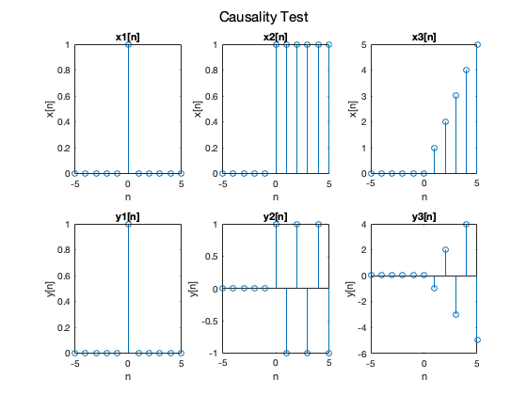

Figure 10. Results after testing causality of System 3

**Linearity**

To determine linearity, two tests must be performed. A test for homogeneity and additivity. If at least one test fails, the system is then non-linear.

Homogeneity

A system is considered homogeneous if when the input is scaled by a certain coefficient, the output is scaled the same way. In figure 11, the six inputs are shown at the top, with the respective outputs shown at the bottom. The first input is simply the step function, while the second input is the step function scaled by 3. When looking at the corresponding outputs, we can already see that the function is homogeneous as the output is also scaled by 3. This phenomenon is further demonstrated for the 5th and 6th inputs in figure 11, which are the ramp function and the ramp function scaled by –1 respectively. In the following set of graphs, input 3 is the unit impulse function, while input 4 is the unit impulse scaled by –5. Homogeneity is demonstrated in the corresponding output as well as it is also scaled by –5. Finally, input 5 is the ramp function while input 6 is the ramp function scaled by –1. The corresponding output is also scaled by –1, therefore system 3 is *homogenous*. To further test if this system is linear, we must test additivity.

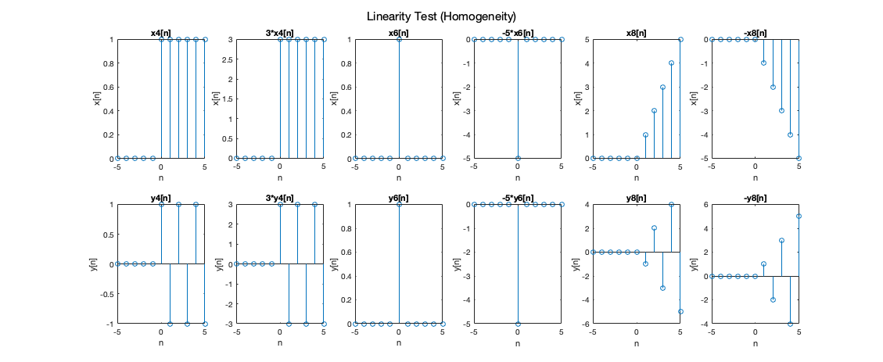

Figure 11. Results after testing homogeneity of System 3

Additivity

A system is considered additive if the output corresponding to the sum of any two inputs is the sum of the two outputs. In figure 13, the six inputs are shown at the top with the corresponding outputs shown beneath them. Inputs 1 and 2, which are the increasing and decreasing ramp functions respectively, are added together to produce the graph for input 3. When looking at the corresponding outputs, y(x1[n] + x2[n]) = y(x1[n]) + y(x2[n]), so therefore, the system is additive for this case. The additive property is further demonstrated in the next case, where inputs 4 and 5 (step functions) are added together to produce the graph for input 6. The corresponding output also demonstrates the additive property of y(x1[n] + x2[n]) = y(x1[n]) + y(x2[n]). Therefore, this system is *additive* and when considering the previous homogenous test, this system is **linear.**

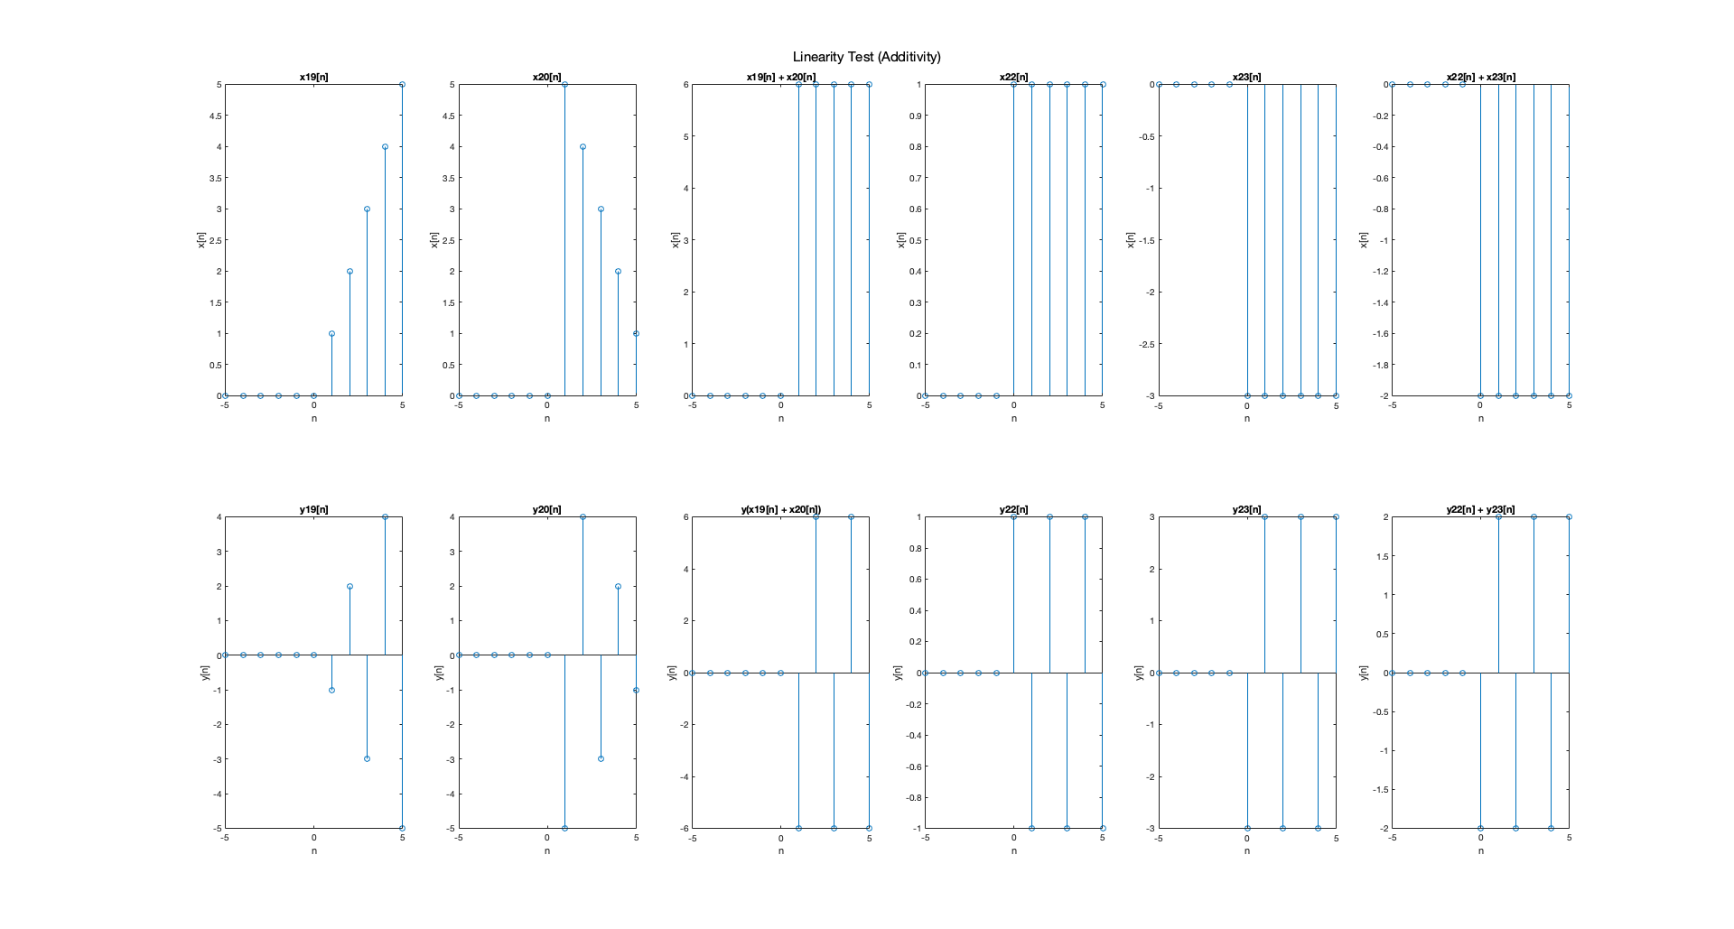

Figure 13. Results after testing additivity of System 3

**Time-Invariance**

A system is considered time-invariant if its properties do not change over time. To test this, one must shift the function and if the output is time shifted by the same amount and not altered, the system is time-invariant. In Figure 13, the first test case uses the unit step function and the unit step function shifted by 2 to the left as inputs. This results in the respective output being shifted by 2 to the left as well. Likewise, in the third test case, the output is consistent and shifts by 4 to the left, the same amount manner the input is shifted by. However, there is a discrepancy in the second test case. When the impulse function input in shift by 3 to the right, the output is shifted by 3 to the right but now has a negative magnitude. This output displays a change beyond a time-shifted input. As a result, system 3 is **time varying.**

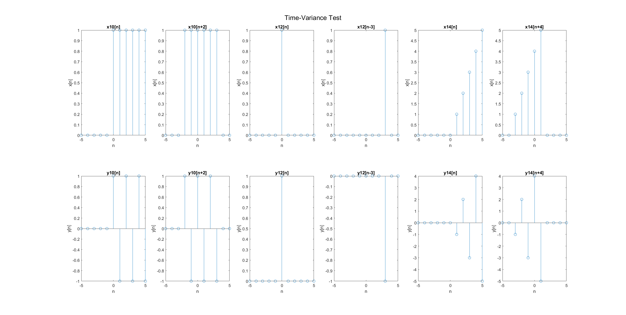

Figure 13. Results after testing time-variance of System 3

**Memory**

A system is memoryless if the present output is only dependent on the present input. In figure 14, the first input is simply the unit impulse function which produces an output that also has a value of 1 when n=0. The other inputs are various shifts of the unit impulse function. They produce outputs that correspond to the same n values. For example, input 2 has values of 1 at n = {-2,0} which produces an output of 1 at the same n values. This is also demonstrated for input 3 which has additional values of 1 at n = {-2,0,2,4}, which result in values of 1 at the same n values in the output graph. As a result, because system 3 only produces an output at the same n value as the input, system 3 is **memoryless**.

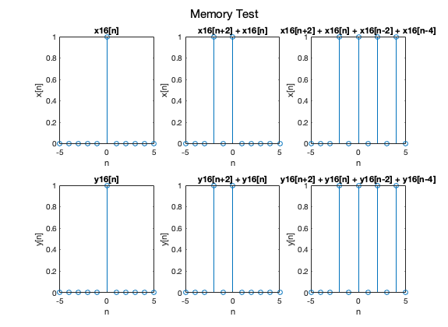

Figure 14. Results after testing memory of System 3

**Conclusion**

After testing for these four system properties, it can be concluded that System 1 is causal, non-linear, time-invariant, and memoryless. In addition, System 2 is non-causal, linear, time-invariant, and has memory. As well, System 3 is causal, linear, time-varying, and memoryless.